**Create transaction to execute SQL statements (ZAWS_RSH_PROCESS)**

You can create any abap program which consume SQL query to functional module ZAWS_RSH_PROCESS and display result in ALV GRID.

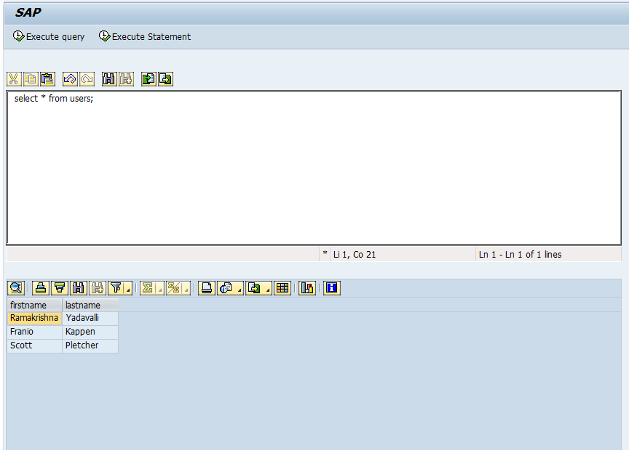

Source Code

1. Main Program - SAPMZ_REDSHIFT_COCKPIT

*&---------------------------------------------------------------------*  
*& Module Pool       SAPMZ_REDSHIFT_COCKPIT  
*&  
*&---------------------------------------------------------------------*  
*&  
*&  
*&---------------------------------------------------------------------*  
  
  
INCLUDE ZSAPMZ_REDSHIFT_COCKPIT_TOP.    " global Data  
  
INCLUDE zi_redshift_cockpit_status_o01.  
  
INCLUDE zi_redshift_cockpit_userco_i01.  
  
INCLUDE zi_redshift_cockpit_performs.

1. PBO

MODULE status_9000 OUTPUT.  
  SET PF-STATUS 'ZRED_9000'.  
  SET TITLEBAR 'ZTITLE_9000'.  
  
*  TEXTAREA  
  IF container is  INITIAL.  
    create OBJECT: container EXPORTING container_name = 'TEXTAREA',  
                   editor EXPORTING parent = container.  
  
    editor->set_text_as_stream( EXPORTING text = text_tab ).  
  ENDIF.  
  IF o_alv_cont IS INITIAL.  
    CREATE OBJECT: o_alv_cont EXPORTING container_name = 'ALV_CONTAINER',  
                   o_grid  EXPORTING i_parent =  o_alv_cont.  
  ENDIF.  
  
  
  
ENDMODULE.

1. PF-STATUS

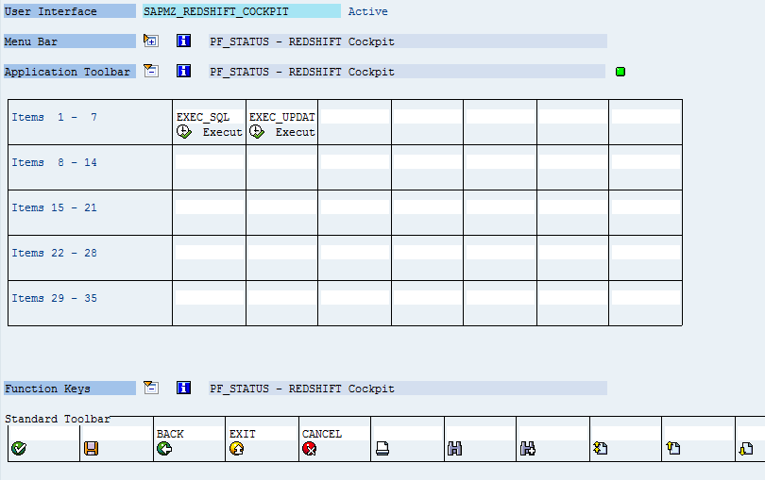

1. Title Bar

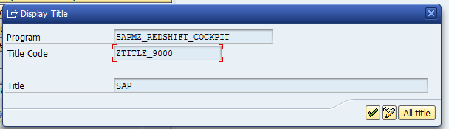

1. PAI

MODULE user_command_9000 INPUT.  
  
  ok_code = sy-ucomm.  
  
  PERFORM process_user_input.  
  
  
ENDMODULE.

1. SCREEN 9000

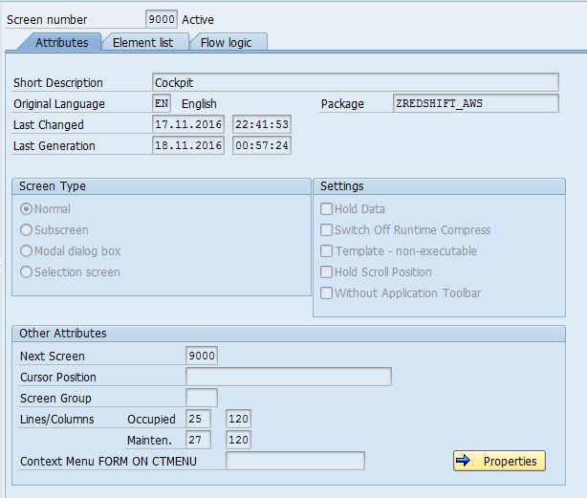

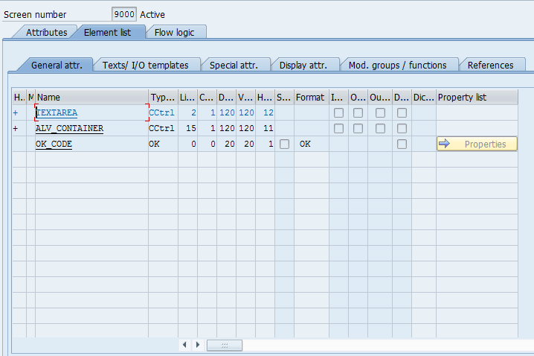

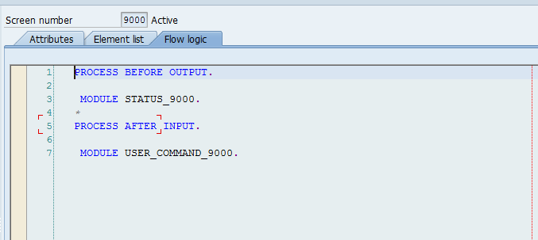

1. Include - ZI_REDSHIFT_COCKPIT_PERFORMS

*----------------------------------------------------------------------*  
***INCLUDE ZI_REDSHIFT_COCKPIT_PERFORMS.  
*----------------------------------------------------------------------*  
*&---------------------------------------------------------------------*  
*&      Form  PROCESS_USER_INPUT  
*&---------------------------------------------------------------------*  
*       text  
*----------------------------------------------------------------------*  
*  -->  p1        text  
*  <--  p2        text  
*----------------------------------------------------------------------*  
FORM process_user_input .  
  
  CASE ok_code.  
    WHEN 'EXIT' OR 'CANCEL' OR 'BACK'.  
      LEAVE PROGRAM.  
  
    WHEN 'EXEC_SQL'.  
      PERFORM send_query_redshift.  
    WHEN 'EXEC_UPDAT'.  
      PERFORM send_update_query.  
    WHEN OTHERS.  
  ENDCASE.  
  
ENDFORM.  
*&---------------------------------------------------------------------*  
*&      Form  SEND_QUERY_REDSHIFT  
*&---------------------------------------------------------------------*  
*       text  
*----------------------------------------------------------------------*  
*  -->  p1        text  
*  <--  p2        text  
*----------------------------------------------------------------------*  
FORM send_query_redshift .  
  
  DATA: lv_sql       TYPE string,  
        lv_line      TYPE line,  
        lv_rows      TYPE i,  
        lt_fcat      TYPE lvc_t_fcat,  
        ls_fcat      TYPE lvc_s_fcat,  
        ls_meta_data TYPE zaws_rsh_s_metadata.  
  
  FIELD-SYMBOLS: <lfs_table> TYPE table.  
  
  editor->get_text_as_stream( IMPORTING text = text_tab ).  
  
  CALL FUNCTION 'CONVERT_TABLE_TO_STRING'  
    EXPORTING  
      i_tabline_length = 255  
    IMPORTING  
      e_string         = lv_sql  
    TABLES  
      it_table         = text_tab.  
  
  
  CALL FUNCTION 'ZAWS_RSH_PROCESS'  
    EXPORTING  
      iv_nonquery = ''  
      iv_sql      = lv_sql  
    IMPORTING  
      et_metadata = t_metadata  
      eo_data     = o_data  
      ev_rows     = lv_rows.  
  
  
  ASSIGN o_data->* TO <lfs_table>.  
  IF <lfs_table> IS NOT ASSIGNED.  
    MESSAGE 'RFC failed to return data' TYPE 'I'.  
    RETURN.  
  ENDIF.  
  
  LOOP AT t_metadata INTO ls_meta_data.  
    CLEAR ls_fcat.  
    ls_fcat-fieldname = ls_meta_data-fieldname.  
    ls_fcat-scrtext_l = ls_meta_data-fielddescr.  
    APPEND ls_fcat TO lt_fcat.  
  ENDLOOP.  
  
  CALL METHOD o_grid->set_table_for_first_display  
    CHANGING  
      it_outtab                     = <lfs_table>  
      it_fieldcatalog               = lt_fcat  
    EXCEPTIONS  
      invalid_parameter_combination = 1  
      program_error                 = 2  
      too_many_lines                = 3  
      OTHERS                        = 4.  
  IF sy-subrc <> 0.  
    MESSAGE 'Failed to display output' TYPE 'I'.  
  ENDIF.  
  
  
ENDFORM.  
*&---------------------------------------------------------------------*  
*&      Form  SEND_UPDATE_QUERY  
*&---------------------------------------------------------------------*  
*       text  
*----------------------------------------------------------------------*  
*  -->  p1        text  
*  <--  p2        text  
*----------------------------------------------------------------------*  
FORM send_update_query .  
  
  
  DATA: lv_sql  TYPE string,  
        lv_rows TYPE i.  
  
  
  editor->get_text_as_stream( IMPORTING text = text_tab ).  
  
  CALL FUNCTION 'CONVERT_TABLE_TO_STRING'  
    EXPORTING  
      i_tabline_length = 255  
    IMPORTING  
      e_string         = lv_sql  
    TABLES  
      it_table         = text_tab.  
  
  
  CALL FUNCTION 'ZAWS_RSH_PROCESS'  
    EXPORTING  
      iv_nonquery = 'X'  
      iv_sql      = lv_sql  
    IMPORTING  
      et_metadata = t_metadata  
      eo_data     = o_data  
      ev_rows     = lv_rows.  
  
  IF lv_rows < 1.  
    MESSAGE 'RFC failed to update' TYPE 'I'.  
    RETURN.  
  ENDIF.  
  
  
ENDFORM.

1. Include - ZSAPMZ_REDSHIFT_COCKPIT_TOP

*&---------------------------------------------------------------------*  
*& Include ZSAPMZ_REDSHIFT_COCKPIT_TOP                       Module Pool      SAPMZ_REDSHIFT_COCKPIT  
*&  
*&---------------------------------------------------------------------*  
PROGRAM sapmz_redshift_cockpit.  
  
DATA: ok_code    TYPE syucomm,  
      init,  
*-- Text Area  
      container  TYPE REF TO cl_gui_custom_container,  
      editor     TYPE REF TO cl_gui_textedit,  
      text_tab   LIKE STANDARD TABLE OF line,  
      t_metadata TYPE zaws_rsh_t_metadata,  
      o_data     TYPE REF TO data,  
*-- ALV Display Container  
      o_alv_cont TYPE REF TO cl_gui_custom_container,  
      o_grid     TYPE REF TO cl_gui_alv_grid.  
FIELD-SYMBOLS: <fs_out_table> TYPE table.